SECTION 713 - BEACHING

##This section cross-references Sections 175, 210, 703 and 801.

If any of the above sections are relevant, they should be included in the specification.

If any of the above sections are not included in the specification, all references to those sections should be struck out, ensuring that the remaining text is still coherent:

713.01 DESCRIPTION

This section covers the requirements for the supply and placement of rock, stone or manufactured block beaching for the protection of batter slopes, drainage channels and culvert endwalls as shown on the drawings. Six types of beaching are covered by this section:

Type 1: Un-grouted rock beaching

Type 2: Grouted rock beaching

Type 3: Grouted flat stone beaching

Type 4: Butted paving block beaching

Type 5: Melbourne Water waterway beaching

Type 6: Armour Stone

713.02 CONFORMITY WITH DRAWINGS

The finished surface of the beaching shall conform to the levels, lines and grades as shown on the drawings or as specified.

713.03 MATERIALS

The Contractor shall supply all materials necessary, including rock or paving blocks, bedding, filter materials, geotextile, concrete, mortar, reinforcement and drainage pipes.

**Prior to the commencement of work, the Contractor shall nominate the source of the proposed materials, supply specified test results and provide a representative sample for approval by the Superintendent.**

Materials used for rock beaching shall be resistant to weathering action of air, wind and water and shall be free from staining, laminations, cracks and other structural defects which may reduce its mechanical strength.

All rock materials used for beaching shall comply with the material requirements for ‘sound’ rock as specified in Section 801 and the Los Angeles Value (LAV) requirements of Table 801.033. The rock shall have a minimum apparent particle density of 2.5 t/m3 when tested in accordance with the requirements of the current Australian Standard - *Method for sampling and testing of aggregates-Particle density and water absorption of coarse aggregate-Weighing-in-water method* as listed in Section 175. In addition, the rock beaching shall have a minimum wet strength of 100 kN and a wet/dry strength variation not exceeding 45% when tested in accordance with the requirements of the current Australian Standard – *Methods for Sampling and Testing Aggregates-Wet/Dry Strength Variation* as listed in Section 175.

(a) Beaching Material

(i) Type 1 - Un-grouted rock beaching

Rock for Type 1 beaching shall consist of field or quarry rock.

All rocks shall have a mass of between 20 and 70 kg and at least 60% by number shall be over 40 kg. Rocks shall be of such size that the layer of beaching is not less than 225 mm thick.

(ii) Type 2 – Grouted rock beaching

Rock for Type 2 beaching shall consist of field or quarry rock. The rocks shall be uniform in colour.

All rocks shall have a mass of between 10 kg and 40 kg and at least 60% by number shall be over 25 kg. Rocks shall be of such size that the layer of beaching is not less than 150 mm thick.

**©** Department of Transport July 2017

Section 713 (Page 1 of 6)

(iii) Type 3 – Grouted flat stone beaching

Type 3 beaching shall consist of dense, flat stone.

Beaching stone shall be uniform in size, shape and colour. Each piece shall be not less than 65 mm thick and have a face area not less than 0.1 m2. At least 50% of the pieces by number shall have an area of more than 0.2 m2.

(iv) Type 4 – Butted paving block beaching

Paving blocks shall be of the type, face size, thickness and colour specified.

All masonry units used for Type 4 beaching shall be solid units and shall comply with the requirements for masonry units in AS/NZS 4455.1. Masonry units shall be sampled to AS/NZS 4456.1 and tested in accordance with AS/NZS 4456.4, and shall have a minimum unconfined compressive strength for masonry units in AS/NZS 4455.1.

(v) Type 5 – Melbourne Water waterway beaching

Rock for Type 5 beaching shall consist of field or quarry rock, preferably of a type/colour that is indicative of the local area.

Primarily the material will be angular in shape, and of even grading (including 5% by weight of rock fines), that creates an interlocked effect when constructed.

The nominal rock size/thickness, D50, is to be specified by the designer and signed off by Melbourne Water. Unless otherwise specified, the minimum D50 shall be a 300 mm rock sizing, with a depth of 2 x D50 (600 mm).

All beaching on Melbourne Water assets shall be structurally stable and scour proof, and as per Melbourne Water requirements. Final Melbourne Water rock beaching is to support agreed revegetation.

**Prior to the commencement of work, the Contractor shall provide a record of Melbourne Water design acceptance to the Superintendent for approval.**

(vi) Type 6 – Armour stone

Armour stone shall comply with the requirements of Type 1 beaching, unless specified, and all armour stone shall have a mass of between ##: and ##: kg and at least 60% by number shall be over ##: kg. Rocks shall be of such size that the layer of beaching is not less than ##: mm thick.

Armour stone used on Melbourne Water assets shall include rock fines to create an interlocked effect when constructed.

**Prior to the commencement of work on a Melbourne Water waterway, the Contractor shall provide a record of Melbourne Water design acceptance to the Superintendent for approval.**

(b) Bedding

Type 1 beaching shall not routinely require a granular bedding, however a very robust needle-punched non‑woven geotextile (mass >250 g/m2) shall be laid over the trimmed surface where rock beaching is to be placed. Geotextiles used shall comply with and be placed in accordance with Section 210. The geotextile shall be buried to a depth of 300 mm at the edges of beaching and placed under and around the excavation for the toe wall and for any other perimeter walls provided. The geotextile shall be laid evenly with no kinks or folds, and joints shall be formed by overlapping the geotextile by not less than 300 mm and not more than 500 mm.

Type 2 beaching shall not require bedding unless specified or shown on the drawings.

Bedding for Type 3 beaching shall consist of at least 30 mm depth of mortar, comprising one part portland cement and nine parts sand.

Bedding for Type 4 beaching shall consist of a 50 mm minimum layer of bedding sand or stabilised sand with a slow setting binder.

**©** Department of Transport July 2017

Section 713 (Page 2 of 6)

Type 5 beaching shall be developed in conjunction with Melbourne Water. The rock used for the granular filter layer is to be well graded and where a granular bedding is required, limited to 0‑100 mm in size. The thickness of the granular filter will depend on site and hydraulic conditions but shall not be less than 100 mm. Sites composed of sandy, dispersive soils may require the use of a geotextile filter layer beneath the granular filter/embedment layer.

Armour stone shall not require bedding unless specified or shown on the drawings.

713.04 PREPARATION OF UNDERLYING SURFACE

Areas on which beaching is to be placed shall be compacted and trimmed as required to provide a finished surface level of beaching in accordance with the drawings. Any scours or hollows in the surface shall be filled with compacted Class 4 crushed rock.

Trimmed material shall be removed from the site.

For treatment of scours and hollows on or near Melbourne Water assets, contact Melbourne Water for the necessary treatment.

713.05 BEACHING PLACEMENT

(a) General

Wherever practicable, the placement of beaching materials shall be by mechanical means. For beaching materials with a mass greater than or equal to 12 kg, placement by mechanical means is mandatory.

Prior to commencement of any work where placement of rock beaching is proposed, a detailed job safety assessment shall be undertaken by a suitably qualified and experienced professional and a suitable Safe Work Method Statement developed to cover all necessary elements.

**The completed job safety assessment and the Safe Work Method Statement shall be submitted to the Superintendent for review.**

The documentation submitted must demonstrate compliance with the Occupational Health and Safety Regulations 2017, in particular, Part 3.1 – Manual Handling, Part 3.3 - Prevention of Falls and Part 5.1 – Construction.

Beaching materials shall be firmly bedded on the prepared embankment and/or bedding if required and laid in courses commencing from the bottom of any slope.

Un-grouted beaching and armour stone when placed shall form a tight ‘interlocking grid’, which shall prevent the removal of individual rocks.

The general surface of the finished beaching shall not vary from a 3 metre straight edge laid across the surface of the beaching by more than:

100 mm for Type 1 Beaching

75 mm for Type 2 Beaching

30 mm for Type 3 Beaching

20 mm for Type 4 Beaching

75 mm for Type 5 Beaching (unless otherwise specified by Melbourne Water Authority)

Finished surface levels of rock beaching placed in open drains shall be flush with adjacent soil levels to allow mowing and maintenance. Rock beaching shall not protrude more than 50 mm above the surrounding ground levels.

The finished rock surface shall be stable to allow public access and shall comply with the requirements of Section 28 of the OH&S Act 2004 ‘Design for Safe Workplaces’.

**©** Department of Transport July 2017

Section 713 (Page 3 of 6)

(b) Type 1 Beaching

Gaps between rocks shall be as narrow as practicable and not exceed 60 mm on average. Voids shall be filled to at least mid‑height of the rocks with topsoil.

The level of the topsoil shall be increased where planting is required within Type 1 rock beaching. The topsoil depth shall be increased to finish flush with the general rock surface and adjacent ground level.

(c) Type 2 Beaching

Width of joints may vary between 10 mm and 60 mm, with an average not exceeding 40 mm. Level difference between edges of adjacent rocks shall not exceed 40 mm. The joint pattern shall be random and the joints kept free from debris before grouting.

(d) Type 3 Beaching

Beaching material shall be thoroughly cleaned and saturated with water before being bedded on fresh mortar as specified in clause 713.03(b).

The joint pattern shall be random and the joints kept free from debris prior to grouting. Width of joints may vary between 10 mm and 60 mm, with an average not exceeding 40 mm. Level difference between edges of adjacent stones shall not exceed 25 mm.

(e) Type 4 Beaching

The blocks shall be placed on the specified bedding sand and laid in accordance with the manufacturer's recommendation. Edge blocks shall be neatly cut to establish straight edges. Dry sand shall be broomed into the joints on completion and lightly watered. The sand used in this mixture shall all pass a 1.18 mm AS sieve and 10‑20% shall pass a 0.075 mm AS sieve.

(f) Type 5 Beaching

Rocks shall be placed to allow for the formation of a tightly interlocked rock mass in which the larger rocks are not free to move. All voids are to be sealed with smaller graded rock for stability and sufficient for water to flow over the top and not within or underneath the beaching. All leading and edge rocks shall finish flush with the surrounding ground level.

The following photos are typical examples of Melbourne Water accepted rock beaching and armour stone showing well graded rock including the proportion of ‘fines’.

**Photo 1: Melbourne Water accepted Type 5 rock beaching**

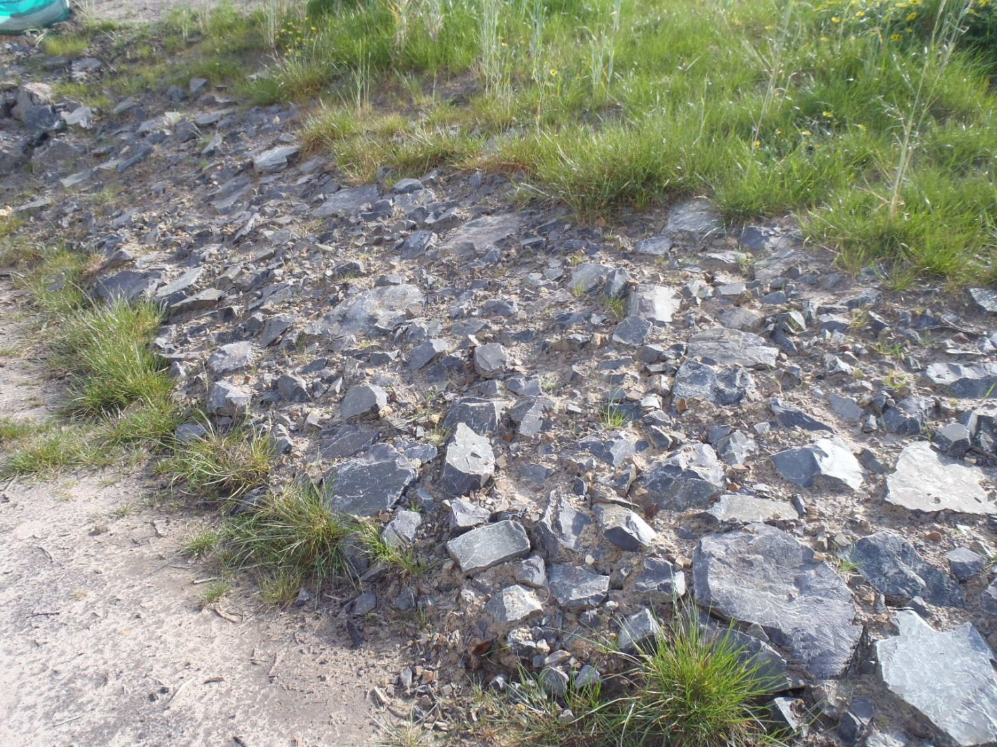

**©** Department of Transport July 2017

Section 713 (Page 4 of 6)

**Photo 2: Melbourne Water accepted Armour Stone**

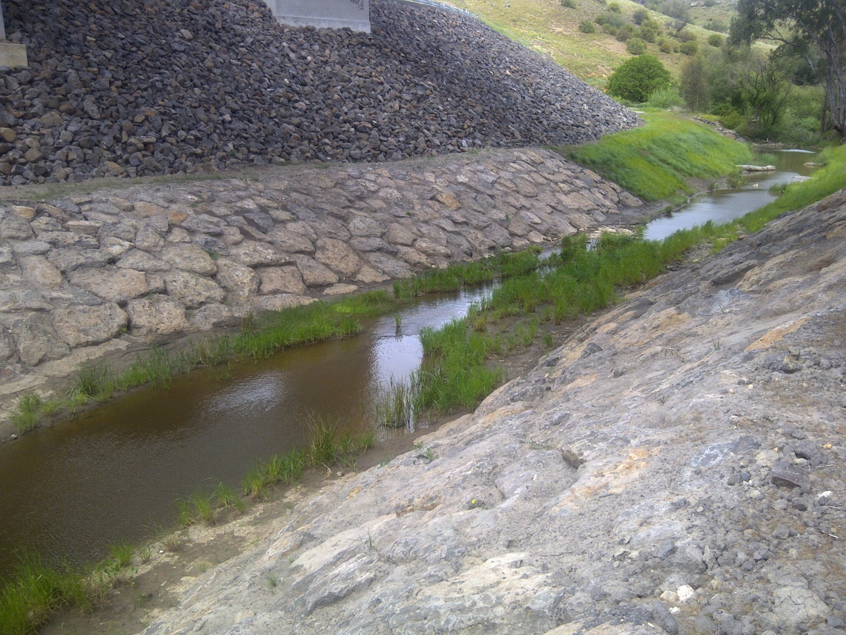

713.06 GROUTING

Grouting with mortar shall be carried out when the air temperature is above 5°C and work shall be kept moist for three days after grouting.

Joint mortar shall consist of one part portland cement and three parts sand by volume, and be thoroughly mixed with water to produce grout of suitable consistency. Propriety cementitious mortars with equivalent performance may be used if approved by the Superintendent.

Grouted rock beaching (Type 2) and grouted flat stone beaching (Type 3) shall be initially placed on a bed of mortar which infiltrates joints and final grouting shall ensure that mortar is firmly tamped into joints to fill the joints to 20 mm below the general top of beaching level.

The joints shall be neatly finished by filling with mortar. The final level of the mortar shall not be within 10 mm of the finished rock surface. Care shall be taken to keep the exposed rock face clean. Brooming of mortar across the face of the rocks will not be permitted.

713.07 PERIMETER AND TOE WALLS

Perimeter and toe walls shall be constructed where shown on the drawings.

For Type 1 Beaching, toe walls 600 mm wide by 600 mm deep shall be constructed. They shall be lined with geotextile fabric and filled with hand packed rock, the larger voids between rocks being filled with smaller stones. Where Type 1 beaching is used in streams, similar walls 600 mm wide by 600 mm deep shall also be constructed across the upstream end of the beaching.

For Types 2, 3 and 4 Beaching, concrete perimeter walls shall be constructed around exposed edges of the beaching. Concrete used for this purpose shall be N20 strength grade complying with Section 703.

Toe walls shall be 300 mm wide by 400 mm deep at the front face and reinforced with L8TM trench mesh top and bottom. The upper surface of the toe wall shall slope upwards at either the slope of the rock beaching or the adjacent verge as shown on the drawings. Side walls and other perimeter walls shall be 150 mm wide by 250 mm deep. The top of the walls shall be continuous with the beaching.

**©** Department of Transport July 2017

Section 713 (Page 5 of 6)

For Type 5 Beaching, perimeter and toe edge rocks will depend on site and hydraulic conditions and shall be constructed in conjunction with Melbourne Water. Perimeter and toe edge rocks shall be trenched into in situ ground before bedding placement. Such rocks shall have a minimum embedment depth of 600 mm and shall finish flush with the surrounding ground.

Perimeter and toe edge rocks may require a granular bedding and an underlying geotextile filter layer, if warranted by the site and hydraulic conditions. All rocks shall be carefully placed into position, rather than dumped directly, so as to avoid segregation of the rock sizes.

713.08 DRAINAGE

(a) Where specified or shown on the drawings, a 100 mm diameter PVC pipe shall be laid down the batter in a trench beneath the bedding to discharge immediately above the top of the toe wall. The pipe shall be securely bedded within the backfilled compacted crushed rock or natural gravel trench.

(b) Weepholes consisting of 75 mm diameter PVC pipes shall be placed through the beaching at 2 m centres immediately above the top of the concrete toe wall and cut off flush with the face of beaching. Weepholes and other drainage lines shall not directly discharge onto areas of public access or shared user pathways.

713.09 CLEANING

On completion of the work, the beaching shall be cleaned to remove all foreign materials and discolouration from the beaching surface. Any joint mortar adhering to the surrounding rock surfaces shall be removed.

**©** Department of Transport July 2017

Section 713 (Page 6 of 6)